***PAAREES PERFUMES***

***DAVIDOFF***

***FOR MEN***

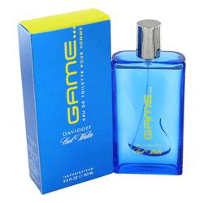

***Cool Water Game***

***Description:***

Cool Water Game by Davidoff Cologne. Cool Water Game by Davidoff is the perfect scent for today's athletic man. Released in 2006, this scent is a mixture of the peppery note of basil, the invigorating quality of grapefruit and the cleansing fragrance of lemon verbena, and it is topped with the tangy character of black currant and the summery freshness of watermelon. Splash on this scent for a burst of confidence before a day of outdoor adventures or before going to the office or class.